Chapter 14, Solution 79.

- Insert a 1-V source at the input terminals.
R_{o}
1/sC
R
+
-
sL
1 V
V₁
V₂
I_{o}
+
V_{o}
-
3V_{o}
+ -

There is a supernode.
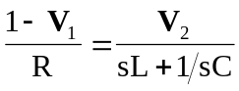 (1)

But 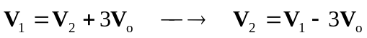 (2)

Also, 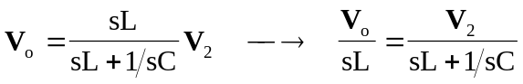 (3)

Combining (2) and (3)
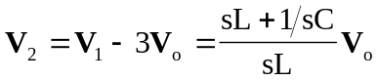
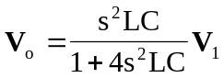 (4)

Substituting (3) and (4) into (1) gives
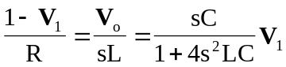
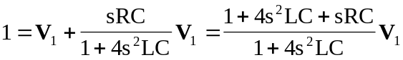
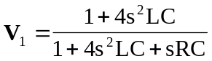

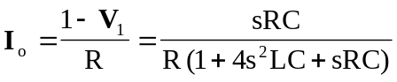

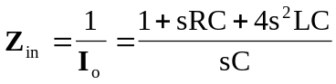
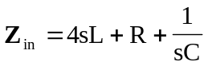 (5)

When 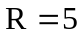, 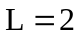, 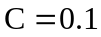,
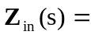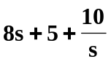

At resonance,
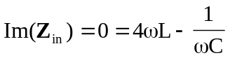
or 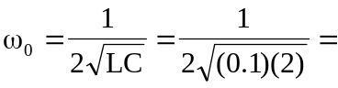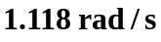

- After scaling,
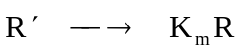
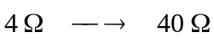
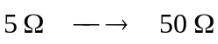

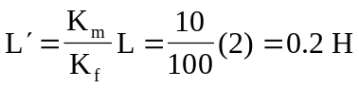

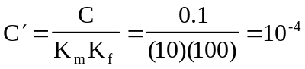

From (5),
